First Grade Newsletter

March 3rd - March 11th
Phonics  This unit will focus on CVVC words that contain the long vowel patterns of ea, ee, ie, and ue. | Reading  The Superkids story selections for the week include Let’s Put on a Play and The Contest: A Play.
Memory Words  Test: Tuesday, March 10th  Please practice the 8 memory words listed on the attached sheet with your child. They should be able to read each word with fluency. | Math  - Adding two-digit numbers  - Using base ten blocks to make a ten to add two-digit numbers  - Telling time to the hour and half hour
Spelling  Test: Wednesday, March 11th  Please see the attached spelling list. This consists of 4 long vowel words, 6 memory words, and two bonus words. Students will be expected to spell all words correctly as they are dictated to them. | Upcoming Events  - March 2nd - No School - Casimir Pulaski Day  - March 11th - Spring Picture Day  - March 17th - 9:30 Late Start
Writing  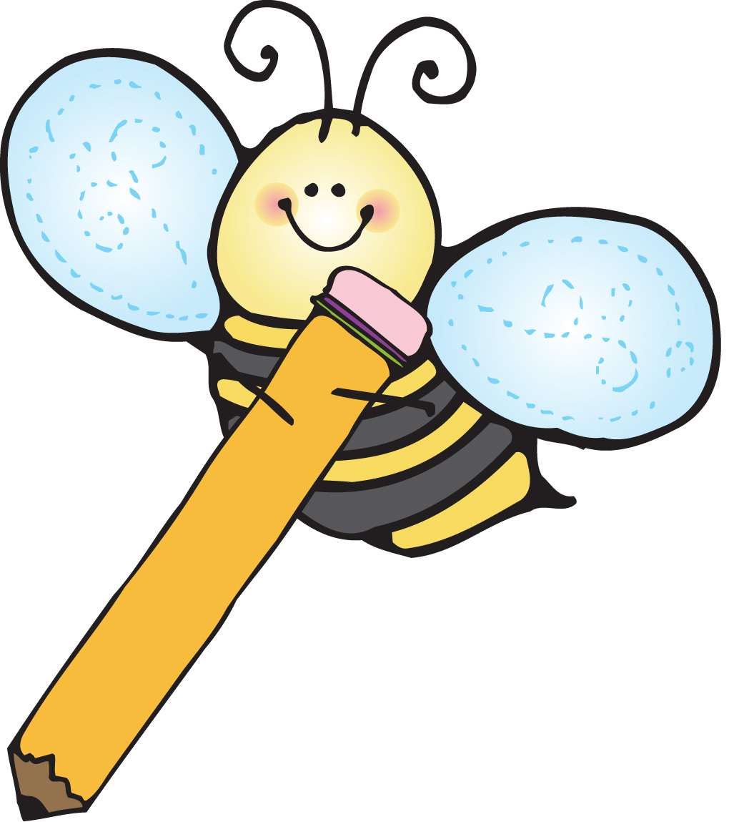  The students have been learning about different parts of a narrative and the importance of including an exciting problem and solution. | Science  In our next science unit we will be the discovery of animals. Students will begin by learning about animal body parts and how they help animals survive.

Unit 8B - Please cut apart the spelling words below and practice reading and spelling them at home.

blue | tie
heat | keep
glue | pie
some | one
new | were
*would | *could

*Bonus Words

Unit 8B - Please cut apart the Memory Words below and practice reading them at home.

reader | each
between | needs
contest | temper
costumes | happened

